**Experiment 06**

**Write a program to implement new activity using explicit intent and implicit intent.**

**Learning Objective:** Student should be able to write a program to implement new activity

using explicit intent and implicit intent in Android Studio.

**Tools:** Android Studio

**Theory:**

Android Studio:

Android Studio is the official integrated development environment (IDE) for Android application development. Every project in Android Studio has one or more modalities with source code and resource files. These modalities include Android app modules, Library modules, and Google App Engine modules. It is an open source software platform and operating system for mobile devices which is based on the Linux kernel. It allows writing managed code in the Java language and Kotlin language. Android apps are built as a combination of components that can be invoked individually. For example, an activity is a type of app component that provides a user interface (UI). The “main” activity starts when the user taps the application’s icon. One can also direct the user to an activity from elsewhere, such as from a notification or even from a different app. Other components, such as broadcast receivers and services, allow the application to perform background tasks without a UI. Intent is a messaging object which passes between components like services, content providers, activities etc. Normally the startActivity() method is used for invoking any activity.

Intent Classification

There are two types of intents:

* Implicit Intent:

Using implicit Intent, components can’t be specified. An action to be performed is declared by implicit intent. Then the android operating system will filter out components which will respond to the action.

* Explicit Intent:

Using explicit intent any other component can be specified. In other words, the targeted component is specified by explicit intent. So only the specified target component will be invoked.

**Implementation:**

**MainActivity.java**

package com.example.ps_exp_6;

import androidx.appcompat.app.AppCompatActivity;

import android.content.Intent;

import android.net.Uri;

import android.os.Bundle;

import android.view.View;

import android.widget.Button;

import android.widget.EditText;

import android.widget.TextView;

import java.net.URL;

public class MainActivity extends AppCompatActivity {

private EditText Name;

private EditText Password;

private TextView Info;

private Button Sign;

private Button Exit;

@Override

protected void onCreate(Bundle savedInstanceState) {

super.onCreate(savedInstanceState);

setContentView(R.layout.activity_main);

Name = (EditText) findViewById(R.id.editTextTextPersonName);

Password = (EditText) findViewById(R.id.editTextTextPersonName2);

Sign = (Button) findViewById(R.id.button2);

Sign.setOnClickListener(new View.OnClickListener() {

@Override

public void onClick(View view) {

Intent intent = new Intent(MainActivity.this, Post_Login.class);

startActivity(intent);

}

});

Exit = (Button) findViewById(R.id.button4);

Exit.setOnClickListener(new View.OnClickListener() {

@Override

public void onClick(View view) {

Uri url = Uri.parse("https://www.google.com");

Intent intent2 = new Intent(Intent.ACTION_VIEW,url);

startActivity(intent2);

}

});

}

}

**activity_main.xml**

<?xml version="1.0" encoding="utf-8"?>

<androidx.constraintlayout.widget.ConstraintLayout xmlns:android="http://schemas.android.com/apk/res/android"

xmlns:app="http://schemas.android.com/apk/res-auto"

xmlns:tools="http://schemas.android.com/tools"

android:layout_width="match_parent"

android:layout_height="match_parent"

tools:context=".MainActivity">

<EditText

android:id="@+id/editTextTextPersonName"

android:layout_width="297dp"

android:layout_height="51dp"

android:layout_marginStart="57dp"

android:layout_marginTop="43dp"

android:ems="10"

android:inputType="textPersonName"

android:text="Enter Username"

android:textColor="#314E45"

android:textSize="20sp"

app:layout_constraintStart_toStartOf="parent"

app:layout_constraintTop_toBottomOf="@+id/textView4" />

<EditText

android:id="@+id/editTextTextPersonName2"

android:layout_width="297dp"

android:layout_height="51dp"

android:layout_marginStart="57dp"

android:layout_marginTop="40dp"

android:ems="10"

android:inputType="textPersonName"

android:text="Password"

android:textColor="#314E45"

android:textSize="20sp"

app:layout_constraintStart_toStartOf="parent"

app:layout_constraintTop_toBottomOf="@+id/editTextTextPersonName" />

<Button

android:id="@+id/button"

android:layout_width="wrap_content"

android:layout_height="wrap_content"

android:layout_marginStart="105dp"

android:layout_marginTop="30dp"

android:backgroundTint="#314E45"

android:text="Login"

android:textSize="16sp"

app:layout_constraintStart_toStartOf="parent"

app:layout_constraintTop_toBottomOf="@+id/editTextTextPersonName2" />

<Button

android:id="@+id/button4"

android:layout_width="wrap_content"

android:layout_height="wrap_content"

android:layout_marginStart="28dp"

android:layout_marginTop="75dp"

android:backgroundTint="#314E45"

android:text="Exit"

android:textSize="16sp"

app:layout_constraintStart_toStartOf="parent"

app:layout_constraintTop_toTopOf="parent" />

<Button

android:id="@+id/button2"

android:layout_width="wrap_content"

android:layout_height="wrap_content"

android:layout_marginStart="30dp"

android:layout_marginTop="30dp"

android:backgroundTint="@color/white"

android:text="Sign Up"

android:textColor="#314E45"

android:textSize="16sp"

app:layout_constraintStart_toEndOf="@+id/button"

app:layout_constraintTop_toBottomOf="@+id/editTextTextPersonName2"

app:strokeColor="#314E45"

app:strokeWidth="5px" />

<TextView

android:id="@+id/textView2"

android:layout_width="wrap_content"

android:layout_height="wrap_content"

android:layout_marginStart="140dp"

android:layout_marginTop="26dp"

android:text="Forgot Password?"

android:textSize="16sp"

app:layout_constraintStart_toStartOf="parent"

app:layout_constraintTop_toBottomOf="@+id/button" />

<TextView

android:id="@+id/textView6"

android:layout_width="wrap_content"

android:layout_height="wrap_content"

android:layout_marginStart="129dp"

android:layout_marginTop="28dp"

android:text="Remaining Attempts: "

android:textSize="16sp"

app:layout_constraintStart_toStartOf="parent"

app:layout_constraintTop_toBottomOf="@+id/textView2" />

<TextView

android:id="@+id/textView3"

android:layout_width="wrap_content"

android:layout_height="wrap_content"

android:layout_marginStart="172dp"

android:layout_marginTop="141dp"

android:text="Welcome"

android:textColor="#314E45"

android:textSize="16sp"

app:layout_constraintStart_toStartOf="parent"

app:layout_constraintTop_toTopOf="parent" />

<TextView

android:id="@+id/textView4"

android:layout_width="wrap_content"

android:layout_height="wrap_content"

android:layout_marginStart="58dp"

android:layout_marginTop="11dp"

android:text="Please Fill the details given below to login"

android:textColor="#314E45"

android:textSize="16sp"

app:layout_constraintStart_toStartOf="parent"

app:layout_constraintTop_toBottomOf="@+id/textView3" />

</androidx.constraintlayout.widget.ConstraintLayout>

**Post_Login.java**

package com.example.ps_exp_6;

import androidx.appcompat.app.AppCompatActivity;

import android.content.Intent;

import android.os.Bundle;

import android.view.View;

import android.widget.Button;

import android.widget.EditText;

public class Post_Login extends AppCompatActivity {

private EditText UserN;

private EditText Name;

private EditText Email;

private EditText Password;

private EditText CPassword;

private Button Login;

@Override

protected void onCreate(Bundle savedInstanceState) {

super.onCreate(savedInstanceState);

setContentView(R.layout.after_login);

UserN = (EditText) findViewById(R.id.editTextTextPersonName);

Name = (EditText) findViewById(R.id.editTextTextPersonName2);

Email = (EditText) findViewById(R.id.editTextTextPersonName9);

Password = (EditText) findViewById(R.id.editTextTextPersonName7);

CPassword = (EditText) findViewById(R.id.editTextTextPersonName8);

Login = (Button) findViewById(R.id.button2);

Login.setOnClickListener(new View.OnClickListener() {

@Override

public void onClick(View view) {

Intent intent = new Intent(Post_Login.this, MainActivity.class);

startActivity(intent);

}

});

}

}

**after_login.xml**

<?xml version="1.0" encoding="utf-8"?>

<androidx.constraintlayout.widget.ConstraintLayout xmlns:android="http://schemas.android.com/apk/res/android"

xmlns:app="http://schemas.android.com/apk/res-auto"

xmlns:tools="http://schemas.android.com/tools"

android:layout_width="match_parent"

android:layout_height="match_parent">

<androidx.constraintlayout.widget.ConstraintLayout

android:layout_width="match_parent"

android:layout_height="match_parent"

tools:context=".MainActivity">

<EditText

android:id="@+id/editTextTextPersonName"

android:layout_width="297dp"

android:layout_height="51dp"

android:layout_marginStart="57dp"

android:layout_marginTop="43dp"

android:ems="10"

android:inputType="textPersonName"

android:text="Enter Username"

android:textColor="#314E45"

android:textSize="20sp"

app:layout_constraintStart_toStartOf="parent"

app:layout_constraintTop_toBottomOf="@+id/textView4" />

<EditText

android:id="@+id/editTextTextPersonName2"

android:layout_width="297dp"

android:layout_height="51dp"

android:layout_marginStart="56dp"

android:layout_marginTop="12dp"

android:ems="10"

android:inputType="textPersonName"

android:text="Enter Full Name"

android:textColor="#314E45"

android:textSize="20sp"

app:layout_constraintStart_toStartOf="parent"

app:layout_constraintTop_toBottomOf="@+id/editTextTextPersonName" />

<EditText

android:id="@+id/editTextTextPersonName9"

android:layout_width="297dp"

android:layout_height="51dp"

android:layout_marginStart="56dp"

android:layout_marginTop="84dp"

android:ems="10"

android:inputType="textPersonName"

android:text="Enter Email"

android:textColor="#314E45"

android:textSize="20sp"

app:layout_constraintStart_toStartOf="parent"

app:layout_constraintTop_toBottomOf="@+id/editTextTextPersonName" />

<EditText

android:id="@+id/editTextTextPersonName7"

android:layout_width="297dp"

android:layout_height="51dp"

android:layout_marginStart="56dp"

android:layout_marginTop="144dp"

android:ems="10"

android:inputType="textPersonName"

android:text="Enter Password"

android:textColor="#314E45"

android:textSize="20sp"

app:layout_constraintStart_toStartOf="parent"

app:layout_constraintTop_toBottomOf="@+id/editTextTextPersonName" />

<EditText

android:id="@+id/editTextTextPersonName8"

android:layout_width="297dp"

android:layout_height="51dp"

android:layout_marginStart="56dp"

android:layout_marginTop="208dp"

android:ems="10"

android:inputType="textPersonName"

android:text="Confirm Password"

android:textColor="#314E45"

android:textSize="20sp"

app:layout_constraintStart_toStartOf="parent"

app:layout_constraintTop_toBottomOf="@+id/editTextTextPersonName" />

<Button

android:id="@+id/button"

android:layout_width="wrap_content"

android:layout_height="wrap_content"

android:layout_marginStart="76dp"

android:layout_marginTop="25dp"

android:backgroundTint="#314E45"

android:text="Sign Up"

android:textSize="16sp"

app:layout_constraintStart_toStartOf="parent"

app:layout_constraintTop_toBottomOf="@+id/editTextTextPersonName8" />

<Button

android:id="@+id/button2"

android:layout_width="wrap_content"

android:layout_height="wrap_content"

android:layout_marginStart="48dp"

android:layout_marginTop="25dp"

android:backgroundTint="@color/white"

android:text="Login"

android:textColor="#314E45"

android:textSize="16sp"

app:layout_constraintStart_toEndOf="@+id/button"

app:layout_constraintTop_toBottomOf="@+id/editTextTextPersonName8"

app:strokeColor="#314E45"

app:strokeWidth="5px" />

<TextView

android:id="@+id/textView3"

android:layout_width="wrap_content"

android:layout_height="wrap_content"

android:layout_marginStart="172dp"

android:layout_marginTop="141dp"

android:text="Welcome"

android:textColor="#314E45"

android:textSize="16sp"

app:layout_constraintStart_toStartOf="parent"

app:layout_constraintTop_toTopOf="parent" />

<TextView

android:id="@+id/textView4"

android:layout_width="wrap_content"

android:layout_height="wrap_content"

android:layout_marginStart="48dp"

android:layout_marginTop="12dp"

android:text="Please Fill the details given below to register"

android:textColor="#314E45"

android:textSize="16sp"

app:layout_constraintStart_toStartOf="parent"

app:layout_constraintTop_toBottomOf="@+id/textView3" />

</androidx.constraintlayout.widget.ConstraintLayout>

</androidx.constraintlayout.widget.ConstraintLayout>

**Design:**

**Implicit Intent:**

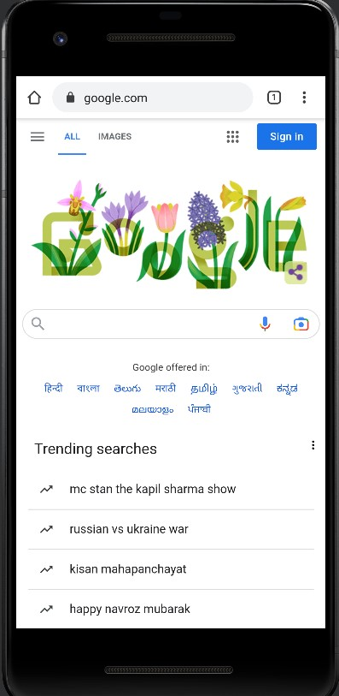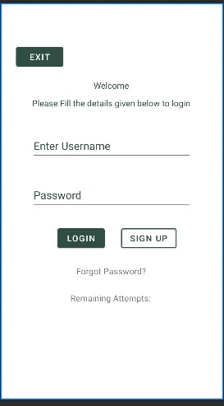

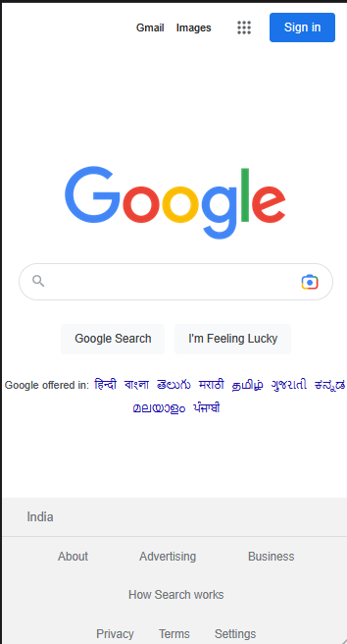

**Explicit Intent:**

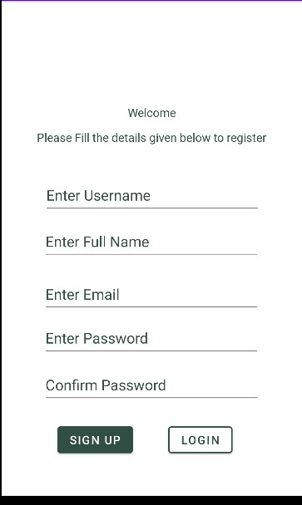

**Result and Discussion:** We successfully implemented a program to execute a program on Android Studio to create a Login Page which uses implicit and explicit intent to switch between pages.

**Learning Outcomes:** The student should have the ability to

LO1: explain what is meant by implicit and explicit intent.

LO2: execute a simple program to create pages to execute implicit and explicit intent.

**Course Outcomes:** Upon completion of the course students will be able to execute a simple

programs illustrating implicit and explicit intents.

**Conclusion:** We understood the concept implicit and explicit intent and how they work in Android Studio. We also successfully executed a program to demonstrate the same. Several concepts related to Android Application Development were revised while performing this experiment.

For Faculty Use

|  |  |  |  |  |
| --- | --- | --- | --- | --- |
| **Correction Parameters** | **Formative Assessment [40%]** | **Timely completion of Practical [ 40%]** | **Attendance / Learning Attitude [20%]** |  |
| **Marks Obtained** |  |  |  |